Emma Pickles

AUTHOR VISIT
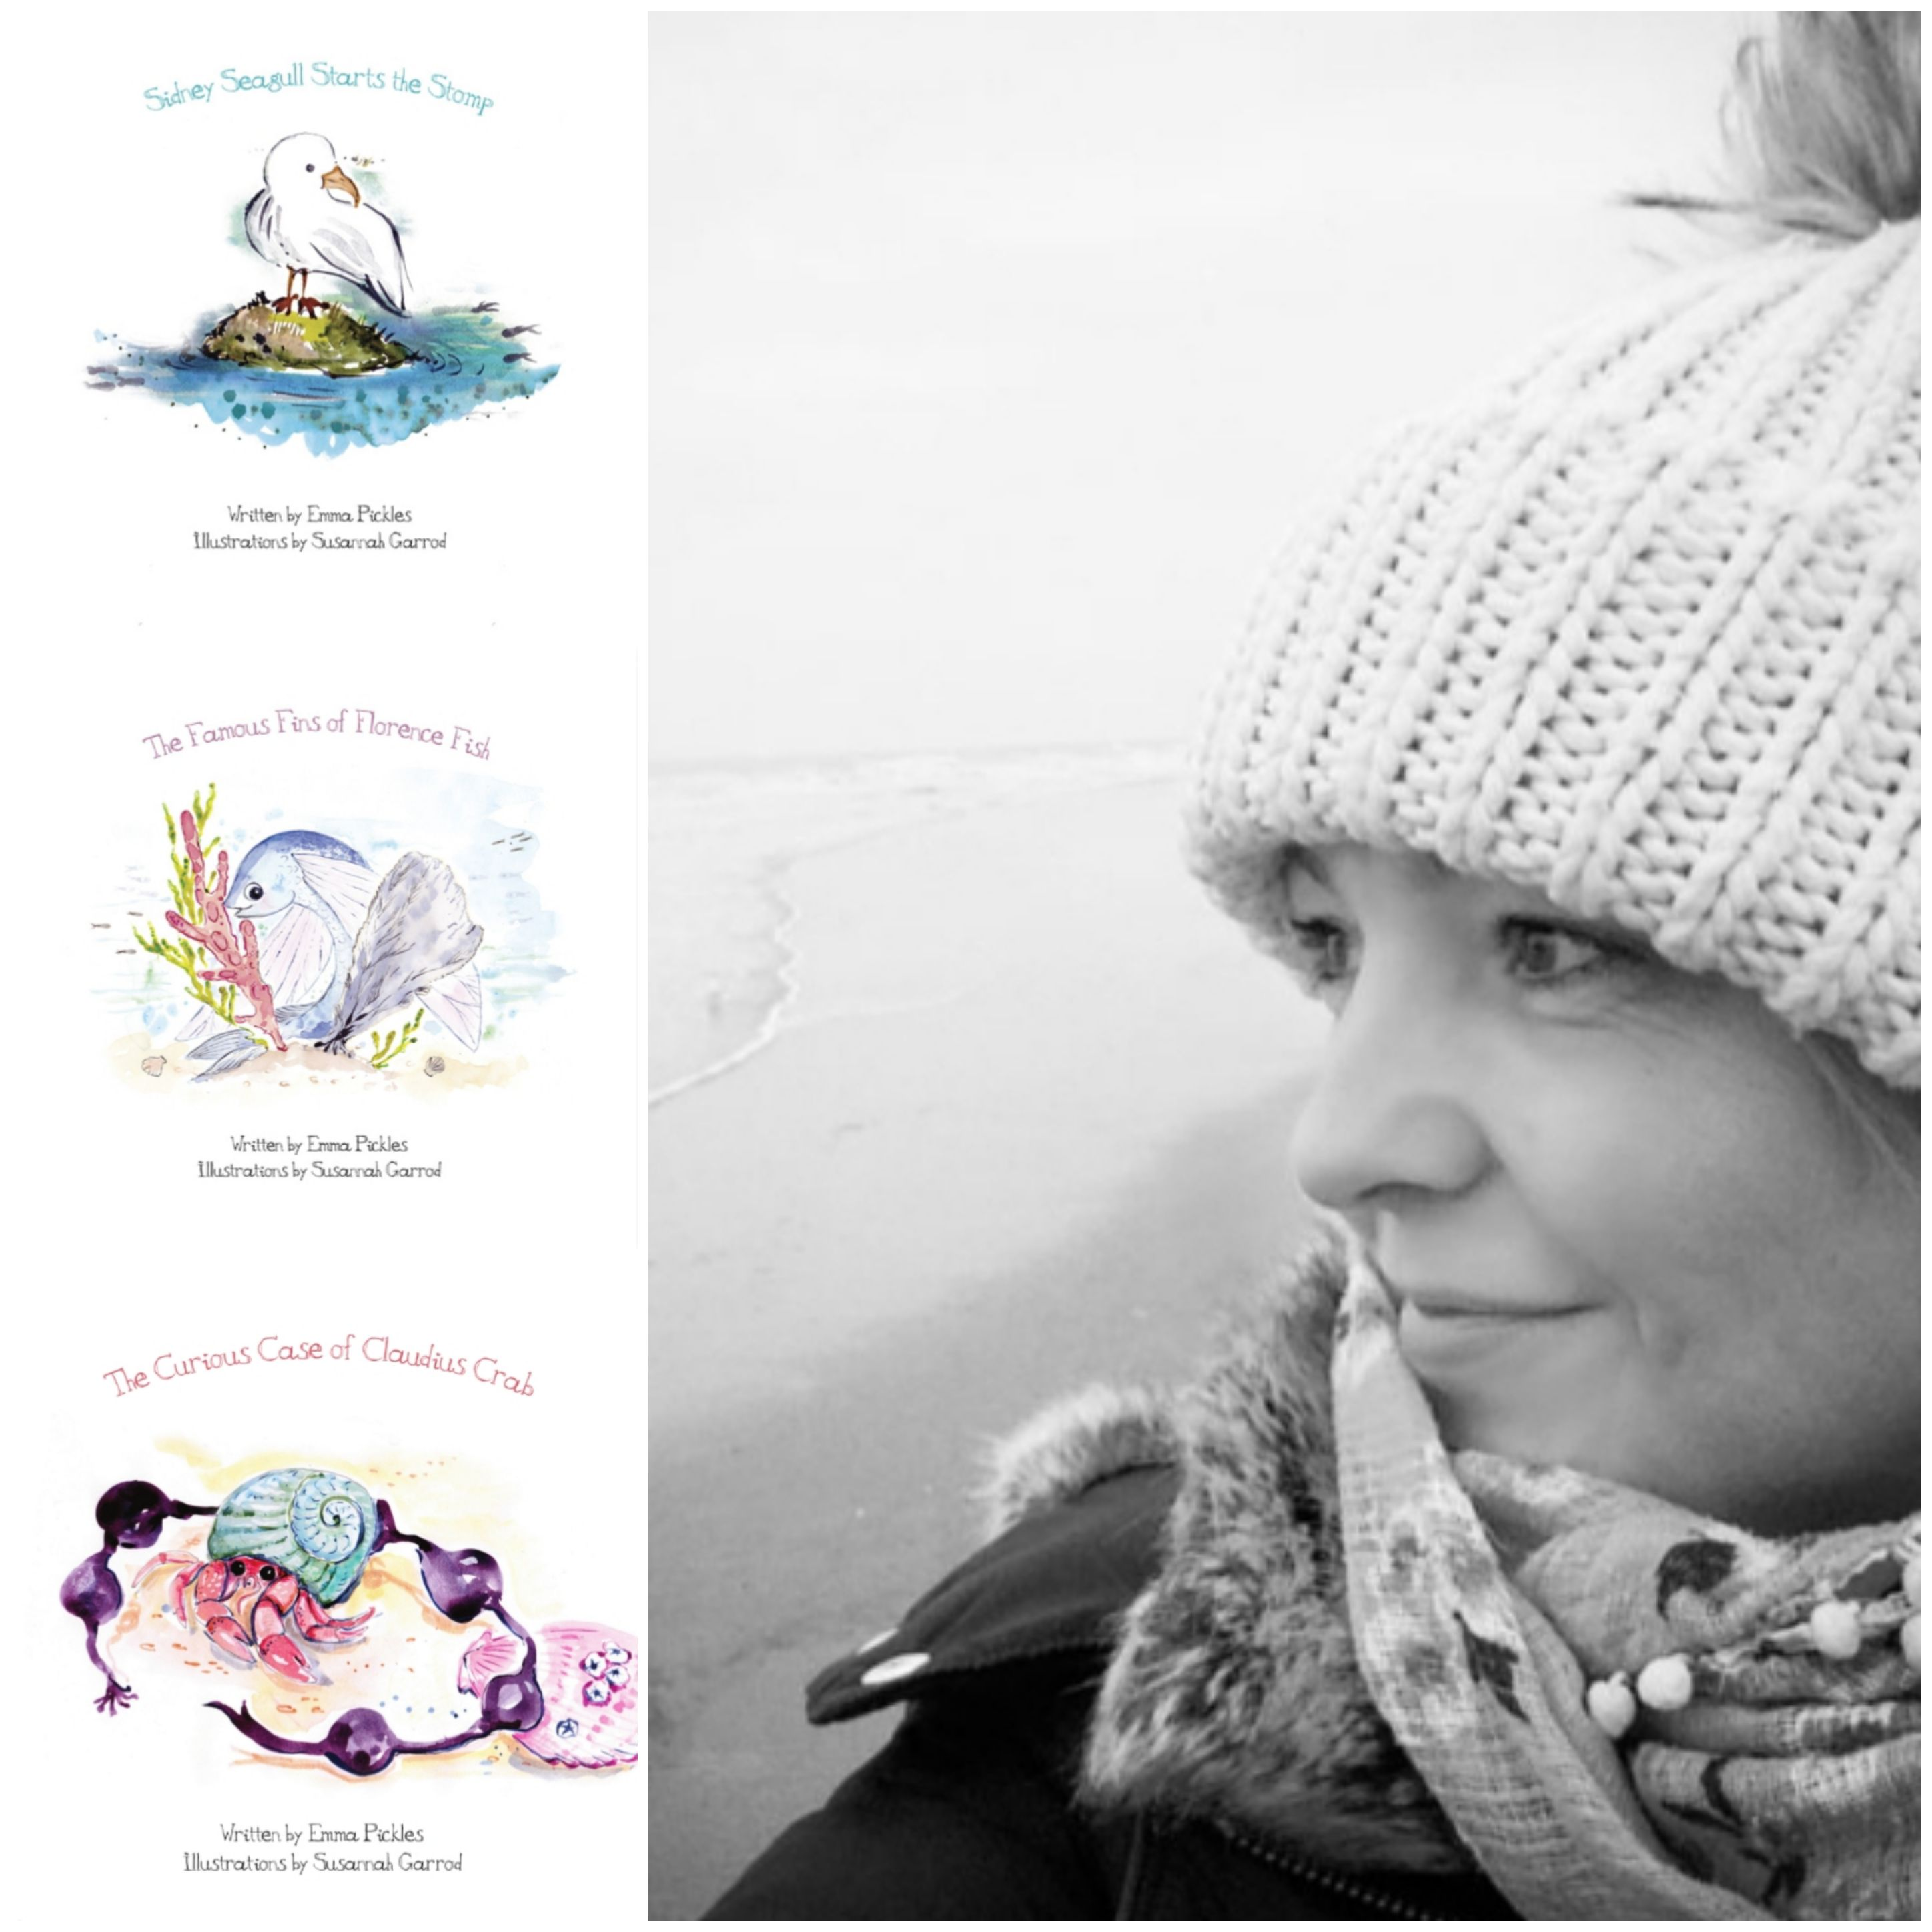

Inspired to write whilst living near the sea, Emma Pickles is a Children’s Author whose books celebrate difference, diversity and inclusion.

CRANWELL PRIMARY SCHOOL Wednesday 6th March 2.30pm

A special Storytime is coming your way during World Book Day week!
  - You can contact Emma @ Gull & Buoy Publishing :
  - 0751 4321 018 : enquiries@gullandbuoy.com

